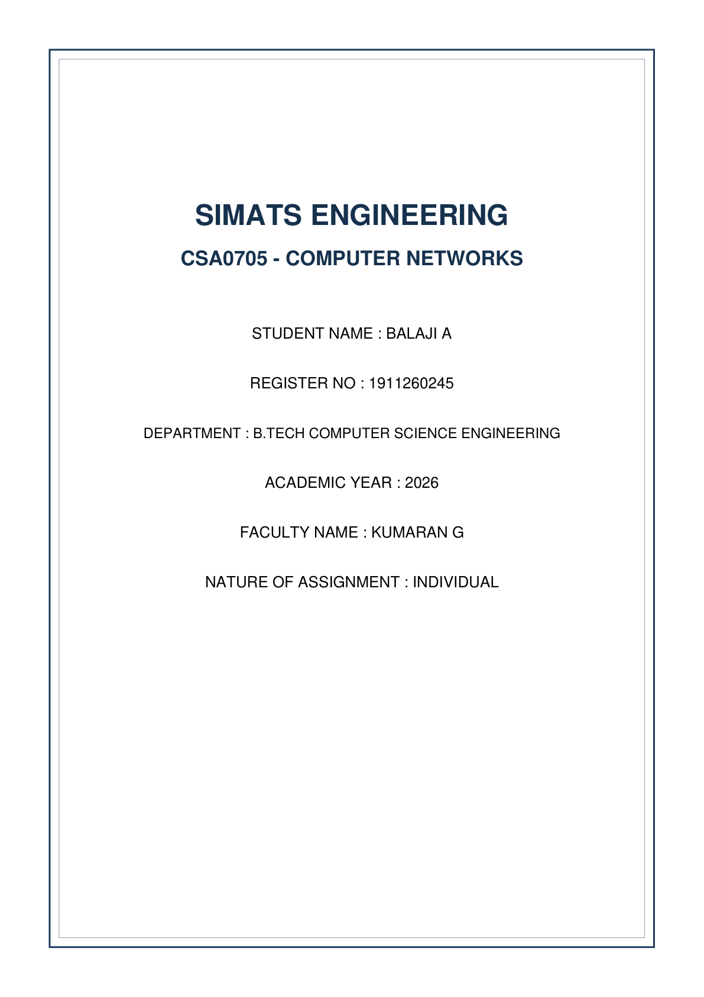


A. Understanding the Question
This question investigates the operational mechanics of Open Shortest Path First (OSPF) metric calculation across modern high-speed link bandwidths. An Internet Service Provider (ISP) network links cities using 10 Mbps, 100 Mbps, 1 Gbps, and 10 Gbps links. After deploying standard OSPF, the ISP notices traffic routing over a 1 Gbps path instead of a parallel 10 Gbps path.
Key Requirements to Solve:
1. Calculate default OSPF costs for all four link speeds using the default reference bandwidth (100 Mbps) and explain why 1 Gbps and 10 Gbps yield identical costs.
2. Select a suitable updated reference bandwidth (100 Gbps), recalculate costs, and execute Dijkstra's Shortest Path Algorithm by hand on a 6-router network topology.
3. Provide Packet Tracer configuration commands using auto-cost reference-bandwidth.
4. Justify single-area vs. multi-area OSPF design for ISP scalability.
5. Provide an Alternative Concept Analysis comparing OSPF against EIGRP and IS-IS.
B. Detailed Step-by-Step Solution & Calculations
1. Default OSPF Cost Calculations & The 10 Gbps Bottleneck
OSPF calculates interface cost using the formula: Cost = ceil( Reference Bandwidth / Interface Bandwidth ).
By default, Cisco OSPF uses a Reference Bandwidth of 100 Mbps (10^8 bps).
• Cost (10 Mbps) = 100 Mbps / 10 Mbps = 10
• Cost (100 Mbps) = 100 Mbps / 100 Mbps = 1
• Cost (1 Gbps) = 100 Mbps / 1000 Mbps = 0.1 -> Rounded up to 1
• Cost (10 Gbps) = 100 Mbps / 10000 Mbps = 0.01 -> Rounded up to 1
The Problem: OSPF costs are stored as positive integers and cannot be less than 1. Because integer rounding forces 0.1 and 0.01 up to 1, both 1 Gbps and 10 Gbps receive a cost of 1. As a result, OSPF treats a 1 Gbps link and a 10 Gbps link as mathematically identical, leading to sub-optimal routing over slower 1 Gbps links.
2. Custom Reference Bandwidth & Recalculated Costs
To distinguish high-speed links up to 100 Gbps, set the Reference Bandwidth to 100 Gbps (100,000 Mbps = 10^11 bps).
• 10 Mbps Link: 100,000 / 10 = 10,000
• 100 Mbps Link: 100,000 / 100 = 1,000
• 1 Gbps Link: 100,000 / 1,000 = 100
• 10 Gbps Link: 100,000 / 10,000 = 10
3. Dijkstra's Algorithm Worked Example (6-Router Topology)
Topology Setup: 6 Routers (R1 to R6).
Links: R1-R2 (1 Gbps, Cost 100), R1-R3 (10 Gbps, Cost 10), R3-R4 (10 Gbps, Cost 10), R4-R2 (10 Gbps, Cost 10), R2-R5 (100 Mbps, Cost 1000), R4-R6 (1 Gbps, Cost 100).
Running Dijkstra's algorithm step-by-step from source R1:
• Step 0: Initial set P = {R1}, Cost to R1 = 0.
• Step 1: Tentative nodes from R1: R2 (Cost 100), R3 (Cost 10). Add R3 to P (Min Cost 10).
• Step 2: Tentative from R3: R4 (Cost 10+10 = 20). Add R4 to P (Min Cost 20).
• Step 3: Tentative from R4: R2 (Cost 20+10 = 30), R6 (Cost 20+100 = 120). Add R2 to P (Min Cost 30).
• Step 4: Add R6 to P (Min Cost 120).
• Step 5: Add R5 to P (Min Cost 30+1000 = 1030).
Result: Traffic from R1 to R2 selects the 3-hop 10 Gbps path (R1 -> R3 -> R4 -> R2, Total Cost 30) instead of the direct 1-hop 1 Gbps link (R1 -> R2, Total Cost 100).
Step | Permanent Set P | Node Added | Shortest Path & Cost from R1
0 | {R1} | R1 | R1 -> R1 = 0
1 | {R1, R3} | R3 | R1 -> R3 = 10
2 | {R1, R3, R4} | R4 | R1 -> R3 -> R4 = 20
3 | {R1, R3, R4, R2} | R2 | R1 -> R3 -> R4 -> R2 = 30
4 | {R1, R3, R4, R2, R6} | R6 | R1 -> R3 -> R4 -> R6 = 120
5 | {R1, R3, R4, R2, R6, R5} | R5 | R1 -> R2 -> R5 = 1030

4. Cisco Packet Tracer OSPF Commands & Area Design
! Cisco IOS OSPF Configuration on R1
enable
configure terminal
router ospf 1
router-id 1.1.1.1
auto-cost reference-bandwidth 100000
network 10.0.0.0 0.255.255.255 area 0
network 192.168.1.0 0.0.0.255 area 0
exit

Area Design Justification:
• Single-Area OSPF (Area 0): Best for networks with under 50 routers. Every router holds the complete Link-State Database (LSDB).
• Multi-Area OSPF: Essential for a large State ISP. Backbone Area 0 connects core sites, while regional cities belong to Standard Areas (Area 1, Area 2). This confines Link-State Advertisements (LSAs) within localized areas, enables route summarization at Area Border Routers (ABRs), and reduces CPU/memory load.
C. Alternative Concept Analysis (OSPF vs. EIGRP vs. IS-IS)
• EIGRP Metric Formula: Composite metric using bandwidth and delay: Metric = [ (10^7 / Min Bandwidth in Kbps) + Sum of Delays ] * 256.
- 1 Gbps link metric: 5,120
- 10 Gbps link metric: 512
• IS-IS Metric: Uses wide metrics (up to 24 bits), giving distinct costs for 1 Gbps and 10 Gbps natively.
• Evaluation: Both EIGRP and IS-IS natively differentiate high-speed links without changing reference bandwidths. However, OSPF remains the open standard choice for multi-vendor networks.
D. Screenshot Guidance for Submission
Network Topology

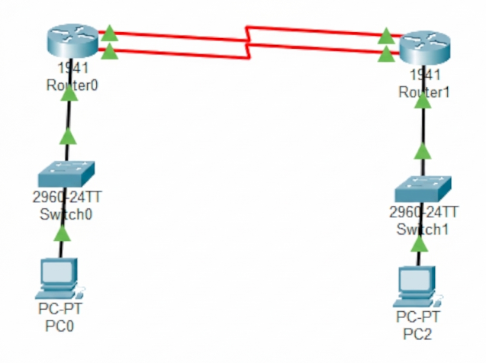

IPv6 Routing Table


